ANGULAR

Ariketa 3 Hola mundo

HTML

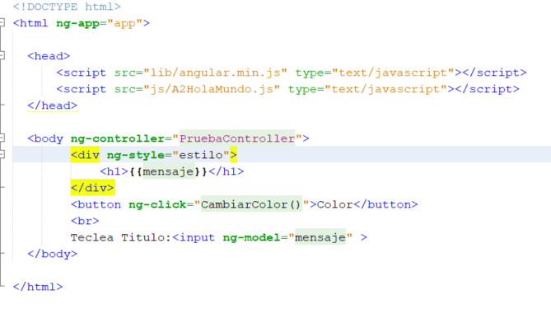

JS

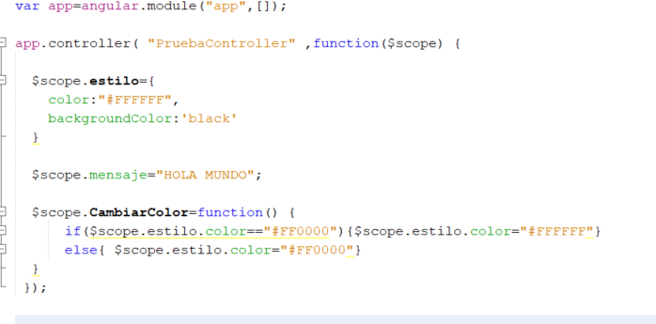

Ariketa 4 TABLA IKASLEAK

HTML

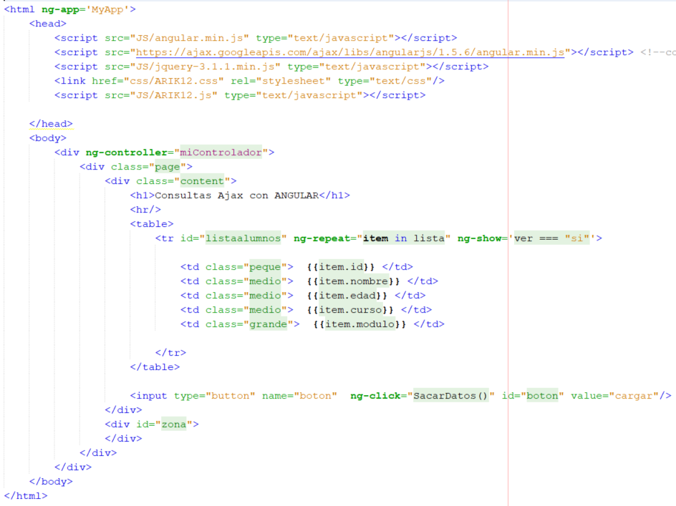

JS

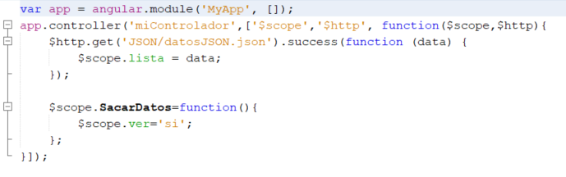

Ariketa 5 COMBO CREAR TABLA LISTA

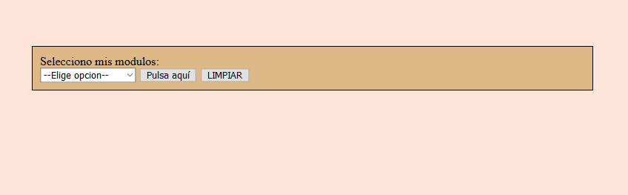

CSS

body{background-color: #fee4d9 } #elegir{margin:40px;margin-bottom: 100px;border:1px solid black;padding: 10px;background-color: burlywood;} table{margin:auto;width:400px;background-color: white} th{background-color: burlywood;color:white;} #resultado {display:table;width:96%;margin:auto} #izda{display:table-cell;width:48%;box-sizing: border-box;} #dcha{display:table-cell;width:48%;box-sizing: border-box; background-color: burlywood;color:white;}

HTML

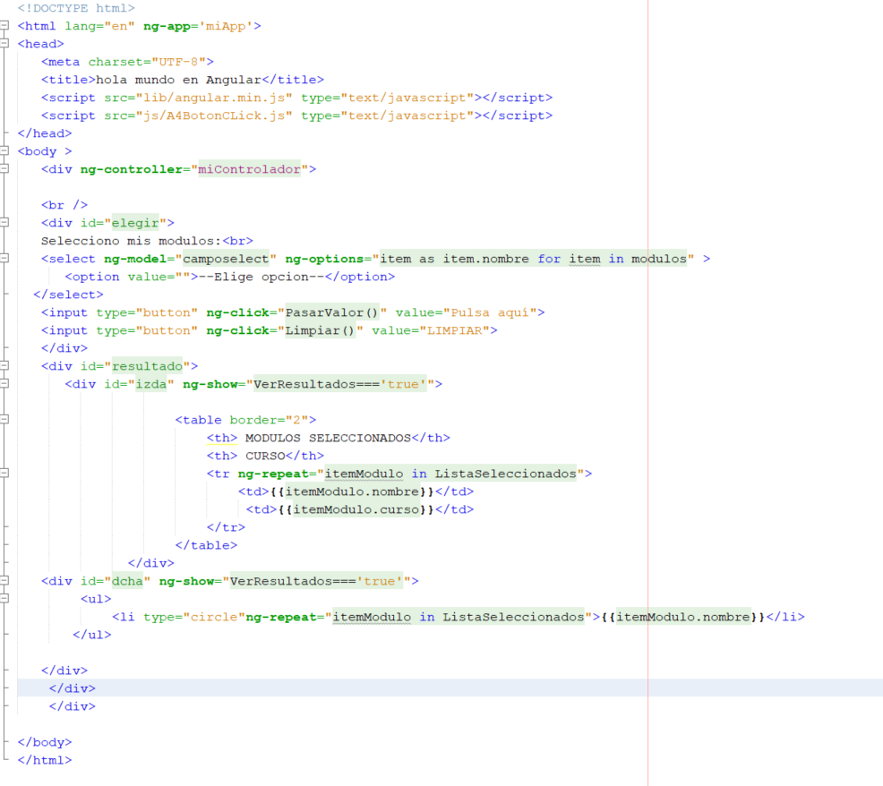

JS

